**ORDER PROCESSING OVERVIEW**

**Order Entry**

Single Item Job Estimates

Two Piece Box Job Estimates

Sets from Estimates

Tandem Piece Box Jobs Estimates  
 Master Tandem Box Orders

Combination/Gang Job Estimates

Farm Out Jobs from Estimates

Finished Goods without Estimates

Stock Boxes, Just in Time

Packaging Supplies

**Release Processing Order Entry**

**Bill of Lading Processing**

**Invoicing**

**Returns**

**Credit Hold and Approvals**

**Web Orders / Electronic Interchange Options**

ASI Anyware Integration

ASIAriba by SAP

Excel Integration

**Order Query**

**Order Reports**

**File Maintenance**

Customers

Order Control File

Sales Price Matrix

Global Price Changes  
 Copy Orders between Companies  
 Miscellaneous Charges

Commission Cost by Items

Import Orders

Data Change Reasons for Release Tab and O-R-14 On Time Deliveries

**ORDER PROCESSING ICONS**

* **Book Icon Finished Goods Notes**
* **Fountain Pen Icon Department Notes**
* **$ Icon for Invoice Specific Notes to print on A/R Aging**
* **Check Mark Icon Job Quality Check List**
* **Machine Icon Job Notes not linked to estimate or FG Item**
* **Paper Clip Icon Attach Graphics, Dies, Directions, etc.**
* **Push Pin Icon Attached Customer PO’s to Order**

**Help Menu** - To expand Estimating Screens Immediately when accessing.



Excel Icon allows users to create custom reports and will transfer estimate data directly to excel file.



Attachments such as customer PO tied to spefic Order and attached to Order Acknowledgment  
  


Column Icon allows each user to move, reduce and expand data columns.



Fountain Pen houses typed notes by for specific machine department for this specific estimate. Yellow Background indicates that notes exist for this item. Icon is identical to item file, orders and jobs.  
  


Paper Clip to Attach Files to the Specific Estimate and Job. Yellow Background indicates data exists.



Book Icon for Finished Goods Item Specific Notes follows all Estimates. Yellow Background Indicates that notes exist for this item. Icon is identical to item file, orders and jobs.



Double Computer Icon allows defning user specific menu for fast access to utilities or programs.



Question Mark is used for screen sensitive help. F3 key is used for field sensitive help.



Circle of Arrows will sort the list of estimates ascending and descending.



Sigma show decimal to fraction chart.

**ORDER PROCESSING – Browser Tab**

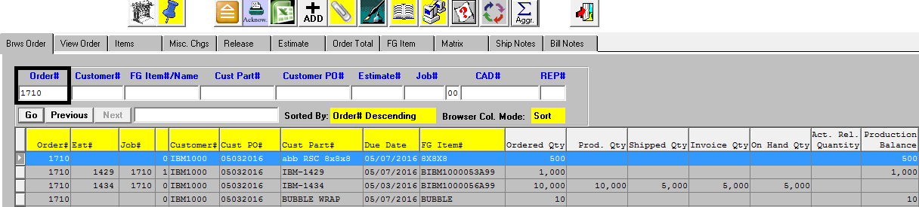

** Attachments specific to Job  
 Order Acknowledgment Print Option**

1. **N-K-1 OEBrowse** To Limit how many orders show on Order Browser.
2. **N-K-1 CustomerList To Limit list of orders by customer based on User ID’s Customer Tab**
3. Customer X Xprint Forms, Default Bin Location and Customer Defaults
4. **Order Browsers Showing ordered, shipped, produced, W.I.P. etc**
5. Wildcard Search Options via * * to Search by Text String
6. Excel Icon Download Orders and Order Query to Create Custom Reports
7. Column Icon Allows each user to move, reduce and expand data columns.
8. **N-K-1 CEMENU** Set Parameter to one Job per Customer Order or Multiple Jobs per Customer Order

ADD TANDEM Button   
Master Estimates allows Customer Service to create new Estimate, Order and Job Simultaneously

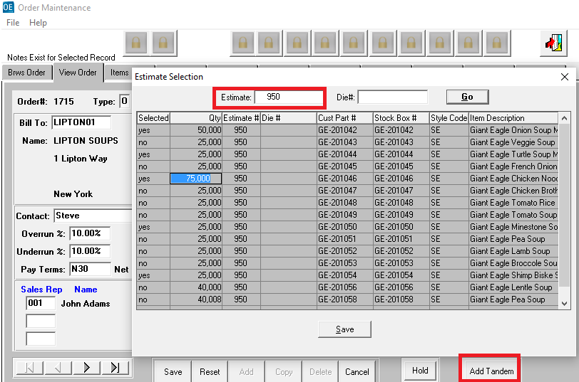

**ORDER PROCESSING – View Tab**

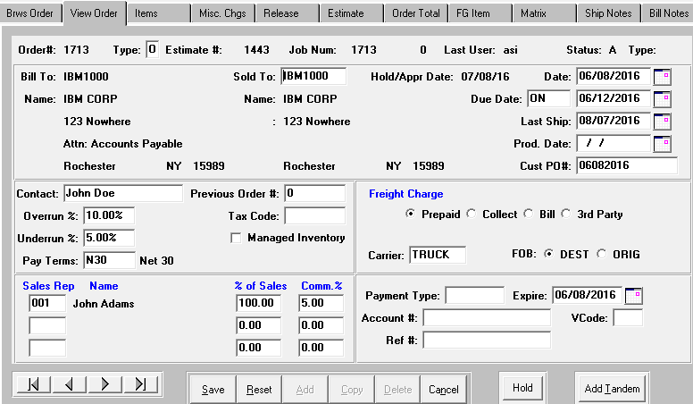

1. CTRL & O Press Keys Simultaneously to Override the Order Number
2. COPY Button Duplicate Orders within Company
3. **N-K-1 JOB#** Job Creation for Purchased Finished Goods
4. **N-K-1 OESetTransfer Creation of Transfer Order to Ship Parts to Contract Packaging Plant for Assembly**
5. **N-K-1 JOBDATESMAX Limit Job Due Date to Integer Value Days from Today?**
6. N-K-1 OEDATE Order Date Updateable
7. N-K-1 LASTSHIP Defatult for Due Date and Last Ship Date Calculated
8. **N-K-1 OrderXfer** Transferring Orders Between Companies
9. N-K-1 OEBROWSE Order Brower and number of records for Order Entry and Order Query
10. N-K-1 OECREDIT Credit Control and Credit Approval and Keeping Orders off hold
11. **Customer X** Xprint Forms, Default Bin Location and Customer Defaults
12. **Customer X** Ship to Locations for Warehouse Transfers
13. **Customer X** Stock Box Items do not verify Customer Code by FG Item
14. **N-K-1 OEScreen New Order Quantity Field and UOM**
15. **N-K-1 OESalesRep View Form for Extra Sales Rep/Mgr & Commission % per Customer**

**ORDER PROCESSING – Items Tab**

** Icon for Jobs ISO / Quality Control  Icon to Print the Job Ticket**

** Icon for Estimate Attached to Job  Icon for FG Item Spec Notes**

** Icon for Texted Based Department Notes  Icon for Date Change Notes**

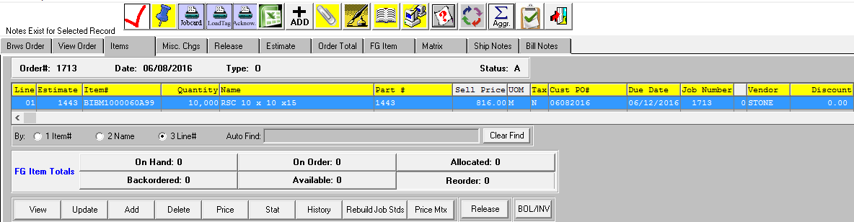

1. **ICON Job Ticket Printing Job Machine Notes vs. Freeze Notes**
2. **ICON for Case Labels Unique by FG Item, Customer Ship To or Customer**
3. **ICON for Load Tags Unique by FG Item, Customer Ship To or Customer**
4. **N-K-1 OEPRICECHECK To check QUOTED PRICES for orders without an Estimate Number**
5. **N-K-1 OESHIP Default Ship To by Estimate or by Ship To when adding FG Items**
6. **N-K-1 OESHIP Logical Value = Yes Adds components of unassembled sets for Shipping.**
7. **N-K-1 OEFGADD Logical Value = Yes To Validate Correctly Typed New Items Code  
    Password Prompt to Create FG Item based on**

**Users Defined on the Program Master Security = OEFGADD.**

1. **N-K-1 FGPART# By Manual Entry, Customer Part# or Category/Customer/Seqequential Number**
2. N-K-1 OEFGUPDT Synchronizing Fields for Estimate, Order and Finished Goods
3. N-K-1 QUOPRICE Custom Box Sell Price via F1 by Quantity and Sell Price and Quantity Match
4. N-K-1 FGPOCOST Farm Outs and Purchase Order Cost linked to Order Entry Cost
5. N-K-1 OEPROMPT Duplicate Customer Purchase Order Prompt
6. N-K-1 OERELEAS Due Date / Last Ship Date and Automatic Scheduled Releases
7. N-K-1 TAXCODE Taxable Customers vs. Taxable Items and Defaults and Customer File)
8. N-K-1 OECOMM Salesman Commission Options by Matrix or Manual
9. N-K-1 FGITEM# Finished Goods Item Number Options
10. N-K-1 OEPOPUP Finished Goods Notes Popup by Spec Code Ensure Old Orders Shipped
11. N-K-1 OEAUTOFG Automatic Vendor Purchase Order Creation for Purchased Finished Goods
12. N-K-1 OEAUTOPO Automatic Vendor Purchase Order Creation for Raw Materials
13. N-K-1 OECOMB Security for Deleting Combination Estimates
14. N-K-1 OEREORDR Order Entry Item Allocated Quantity
15. N-K-1 FGColors Update FG Color for Estimate Inks (Offset and Flexo Presses in Same Plant)
16. N-K-1 OEREORDRUse Actual Releases to calculate Quantity Allocated in Order
17. **N-K-1 OEPriceCheck To import quote pricing for Purchased Items not Estimated**
18. **N-K-1 OERound** Integer Value 2-6 to Round Sell Price up to 6 Decimals
19. **N-K-1 OEPOPUP** Overrun Inventory Prompt when Log Value = Yes & Char Value = Spec Code
20. **Program Master Security for N-K-1 OeAutoPO, OEAutoFG and OEAutoPrep**

**ITEMS TAB - BUTTONS & FIELDS**

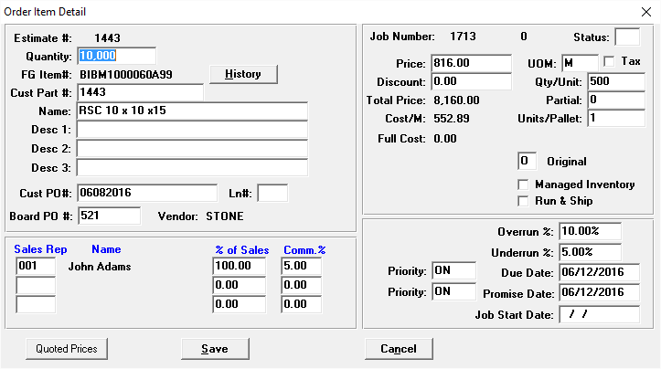

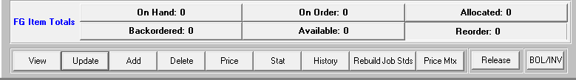

1. **FG ITEM BUTTONS:** ON HAND, ON ORDER, ALLOCATED, AVAILABLE
2. **HISTORY Button** ADD FG item with Historic Price and History of Sales via Enter Key
3. **HISTORY Button To Show Pricing History**
4. **VIEW / UPDATE**  Sort by Line#, Item#, Name and the Field LN#
5. **QUOTED PRICES** Shows Quoted sales prices for FG items with Estimates
6. **N-K-1 OECount** Default for Unit Count by Case or by Pallet from Estimate
7. **Full Cost FG Item Field to Include Freight Cost for Purchased Items**
8. **Promise Date**
9. **Job Start Date Integrated with Jobs Start Date and Schedule Board**
10. **Item Status Original New, Repeat, Change for Job Ticket Information**
11. **Managed Inventory Warehouse Toggle for Job Ticket Information with Job Quantity Minus Overrun**
12. **Run & Ship Management for Factory Ticket and Release Quantity**

**ORDER PROCESSING Release Tab Options**

1. N-K-1 REBROWSE Release Browser to Show Number of Records
2. N-K-1 OERELEAS Log Value = Yes Automatic Scheduled Release Creation During Order Entry
3. N-K-1 AUTOREL Creating Releases via Order Entry, Order Inquiry or via O-T-1
4. **N-K-1 ADDRELSE** Char Value Options: **No Tags**, Bin/Tags by Job, All Jobs
5. N-K-1 RELMERGE Integer Value Validates Job Number. Log Value to Merge Printed Releases
6. N-K-1 RELMERGE Char Value: How to Merge Releases when pressing Release Button  
    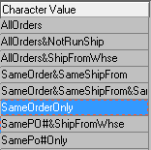
7. **N-K-1 ADDRELSE** Warehouse Release Processing via Orders, Inquiry or Add
8. **N-K-1 ADDRELSE** Decimal Value = 1 will search only open jobs to speed Release Process
9. **N-K-1 OEPO#Xfer** Option to Transfer Purchase Order# on Order to Unposted Invoice
10. **N-K-1 OEDateChange** New Date Change File and On Time Reporting
11. **N-K-1 FGPost – Int Val = 1** Update Release Qty via FG Receipt on Job Overruns & Run & Ship = Yes

For Unreleased or Unprinted Release, Replace Entire Release Quantity

For Printed or Posted Release then Add New Release for Overrun Quantity

1. INVOICE and BOL Buttons Invoice Only, Ship Only, Transfers in One Easy Step
2. **Customer Ship To Notes Release Notes and Option to Transfer to Bill of Lading in Process**
3. Release Button E-Release ECODE EMAIL confirmation when O-T-1 Release is Created
4. SET Button Release for Simultaneously Release of Unassembled Components

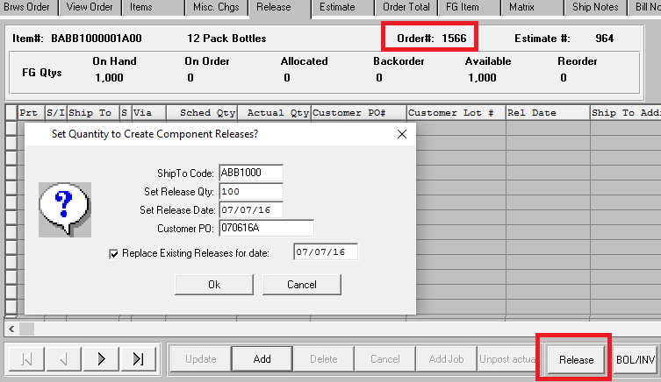

**ORDER PROCESSING RELEASE TAB FIELDS**

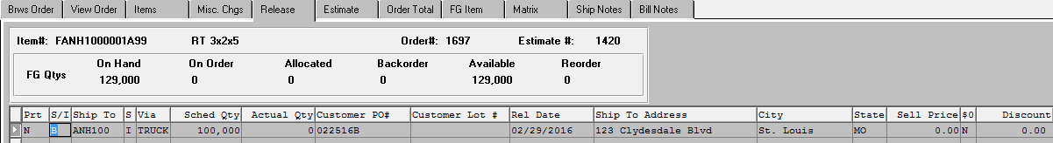

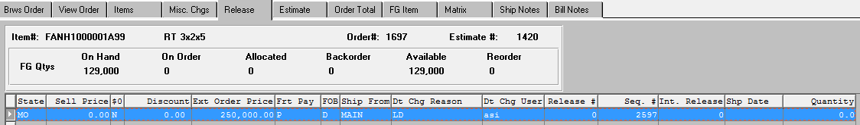

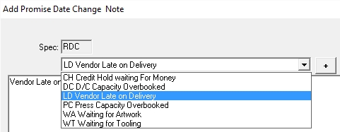

1. S/I N-K-1 RelType to Default Ship Only, Invoice Only, Transfer or Both Ship and Invoice
2. Ship To Location of Customers Locations. For Transfers Includes Customer Status X
3. S Status Release Status Codes: Scheduled, Invoice, Completed, Late, Posted, Backorder, Actual
4. Via Ship Via Method such as UPS, FedX, Our Truck, etc.
5. Release Quantity Scheduled Ship Quantity (Automatic Updating via Select Bins / Tags)
6. Negative Quantity Inventory Returns as Negative BOL Quantity and Negative Invoice Quantity
7. Actual Quantity Updated after Shipment of Bill of Lading Posted to create the Invoice
8. PO # Unique PO# by Release
9. Lot Number Downloaded to Load Tag Text File
10. Rel Ship Date O-F-9 New Date Change Reason File and Spec Code RDC
11. Sell Price Override by Release Date for Special Sales Pricing such as Job Overruns
12. Sell Price Override by Release Date for Special Sales Pricing such as Job Overruns
13. 0$ Yes will create Invoice for Zero Dollars
14. Discount Discount off Sell Price Imports from Items Tab via Customer File
15. Freight Payment Method of Freight Payment as Prepaid, Collect, Bill or Third Party
16. FOB Freight on Board as Destination or Origin
17. SHIP FROM User File Defaults Warehouse by Release for F.G. Reorder Advise by Warehouse
18. Date Change Reason Users with Security via OEDateChg.r can Select Reasons Codes are defined in O-F-9
19. Date Change User The User ID that changed the Release Date
20. Release# Actual Release Number via O-T-1 was shipment is released
21. Int Release# Internal Release# which is maintained by system for unreleased Releases
22. Ship Date Bill of Lading Date once Bill of Lading is Created and Posted
23. **N-K-1 RELPOST**  Release Posting Options: BOL, BOL/REL, BOL/Tag, Invoice, Nothing

**ORDER PROCESSING - Miscellaneous Tab**

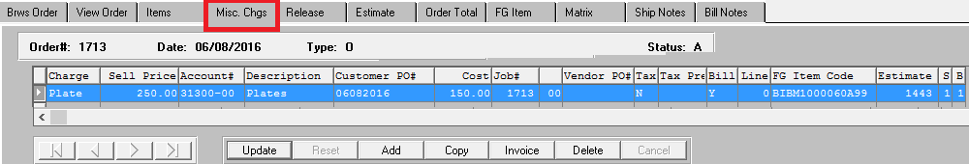

1. **N-K-1 OEAutoPrep** Automatic PO creation for Prep Charges, which assigns PO# to Misc Charges Tab
2. **N-K-1 JCPrep** Raw Material Codes Created for Prep Material for better Job Costing and Scheduling
3. N-K-1 OEPREP MISC folder for Prep and Dies to link to Estimate and Purchased Cost
4. **Misc Charge Prep Codes from Estimate imported from E-B-8 or manually added**
5. **Misc Sell Price Dollars to be Invoiced import from the Estimate but may be added or changed**
6. **Account# G/L Account Revenue Number from E-B-8 Prep or RM Material Cost Type File**
7. **Description G/L Account Number Description**
8. **Freight Charges Freight Table and Freight Classification by FG and BOL**
9. **Freight Charges Freight Table and Freight Classification by FG and BOL**
10. **Customer PO# PO# Transfers from the FG Item PO# but may be Changed**
11. **Cost Cost in Dollars imports from the Estimate but may be added or changed**
12. **Job# Job# must be assigned when manually adding Prep.**
13. **Vendor PO# Purchase Order # from Vendor PO**
14. **Invoice Button** To Invoice prior to shipping Finished Goods
15. **Tax Tax Code for Billable Prep Charges**
16. **Sales Reps Sales Reps Code with Up to 3 Reps to Receive Commissions on Prep Charges**
17. **% of Sale Percentage of Invoiced Prep Dollars that will be used to Calculate Commissions**
18. **Comm % Commission Percentage that is Multiplied by % of Sale times Invoiced Prep Dollars**
19. **INVOICE Button Immediate Invoice Creation prior to Shipping Finished Goods**

**ORDER PROCESSING – Order Total Tab**

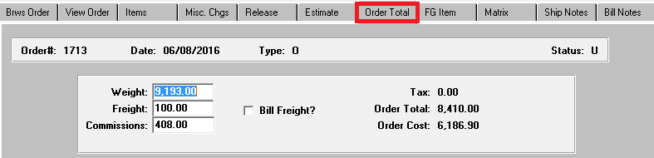

**ORDER PROCESSING – Bill Notes Tab Default by Group Code BN**

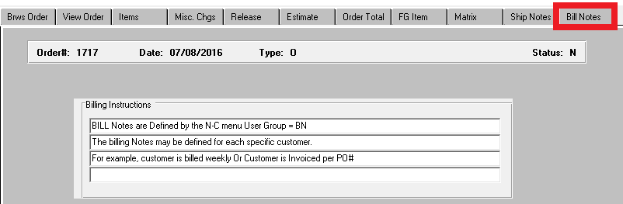

**By Customer**

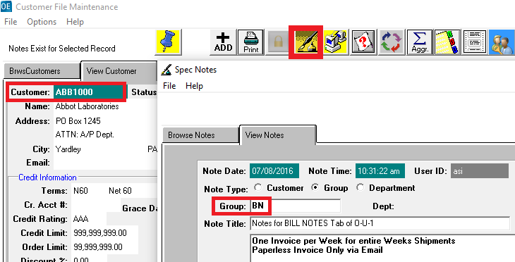

**By Box Plant  
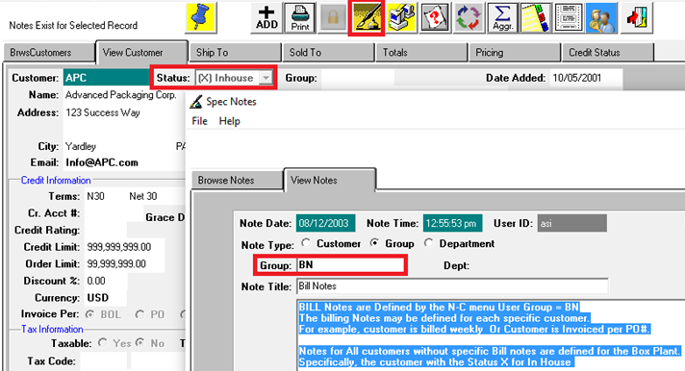**

**ORDER PROCESSING – SHIP TO NOTES TAB**

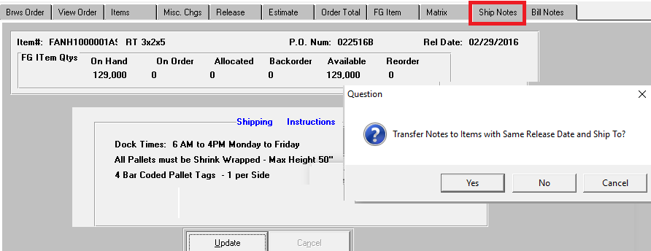

**ORDER PROCESSING O-T-1 Release Processing**

**+ ADD** Add Release for Multiple Orders by FG Item or by Order  
Ideal for Large Customers with Blanket Orders with Distribution Centers throughout the USA

Import an Entire Order

Add Specific Finished Goods items

N-K-1 RELCREDT Credits Credit limits when adding new release. Same logic from Release Tab   
 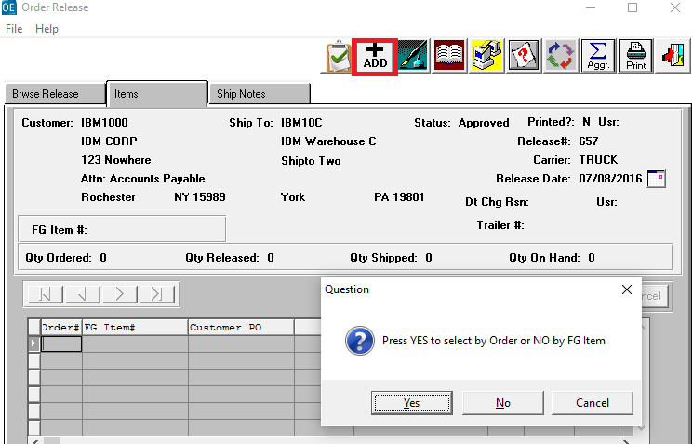

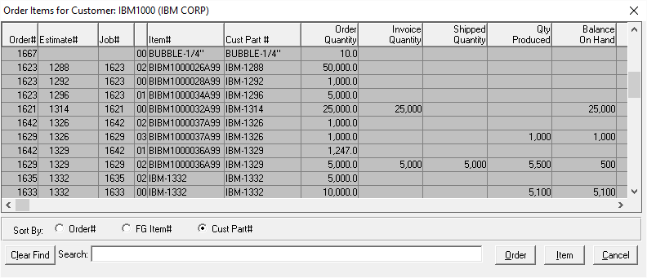

O-T-5 Truck Planning By Order for Excel Truck Routing

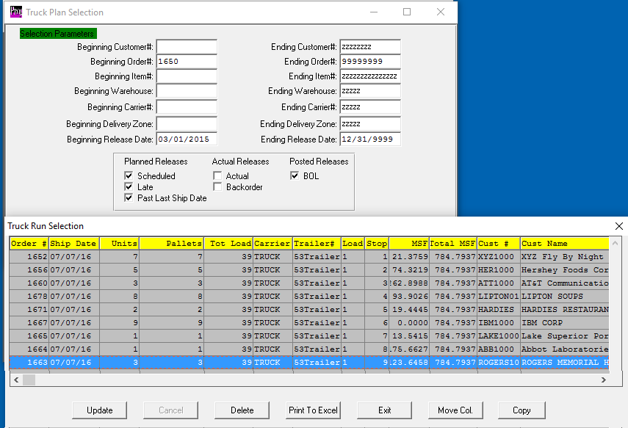

**PRINTS AN EXCEL FORM BY TRUCK DRIVER BY LOAD# AND STOP#**

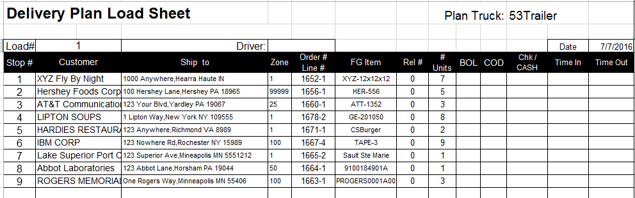

**ORDER PROCESSING - Bills of Lading Options**

1. Bill of Lading Browser Posted Toggle Box to Show Shipment History
2. **N-K-1 BOLDATE** Bill of Lading Date by Release Date or Current Date for On-Time Deliveries Report
3. **N-K-1 BolSIGN Scanning Bill of Lading with Signatures and Reprinting via Icon**
4. **N-K-1 BolFmt** View Form for BOL Forms per Customer
5. **N-K-1 BolFmtX** To print BOL Form via O-S-1 Toggle Box “Print Freight Bill /Logo?
6. **N-K-1 CInvoice** Business Format for Commercial Invoice to Mexico
7. **N-K-1 BOLCert** Certificate of Compliance Format and Option to print BOL and COC Simultaneously
8. **N-K-1 BOLWeight** Manually Set Pallet / Carton Weight rather than use Wt/100 from FG Item File
9. **N-K-1 SSTransF** Char Value = FGItem allows Ship Method by Case for Partial Pallet Tags
10. **N-K-1 BOLPOST** Integer Value = 1 Will Not create I-U-2 Transfer (Remote Whse Does Xfer)
11. **N-K-1 BOLPOST** Logical Value = Yes Creates both Receipt and Shipment to Zero On Hand
12. **N-K-1 RELPOST Decimal Value 1 to force C for completed in the BOL Partial / Complete Field**
13. N-K-1 ADDRelease (Log Value = No) Stops Backorder Releases from Bills of Lading
14. N-K-1 UPSFile Integration to UPS when Trailer ID = UPS
15. N-K-1 ADDRELSE N-K-1 RELPOST combine to provide Bill of Lading Creation Options
16. N-K-1 RELPOST Creates 1 BOL per Release or Combines Multiple Releases onto 1 BOL.
17. N-K-1 PackSlip BOL Toggle Box " Print Bar Coded Pack List? To create Text File for Label Matrix
18. Multiple Orders/BOL Combining per Bill of Lading
19. Reprinting BOL Reprinting Posted Bill of Ladings for History
20. **BOL Broker Options BOL Print Options**
21. **Post Toggle Box Immediate Invoice to Create Back Orders Same Day as Shipment.**
22. Combining BOLS Changing Bill of Lading Number
23. **Emailing ASN Advanced Ship Notices with Ecodes program B-ReLBoL**
24. **TruckLoad BOL O-S-6 Truck Load BOL Summary Report / Form**
25. **Truck Planning Truck Load Scheduling to Create Excel based Delivery Schedule by Truck**
26. **BOL Pallet Tag Creating Single Pallet Tags for Multiple Bill of Ladings**

**N-K-1 BolFmt View Form for Unique Bill of Lading by Ship To or Customer**

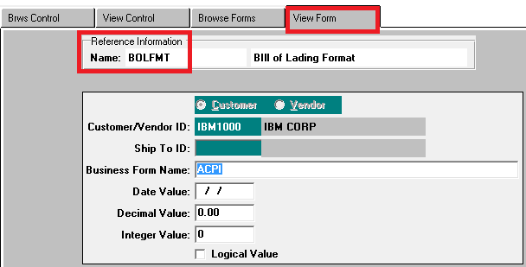

**ORDER PROCESSING - Bills of Lading Toggle Box Options**

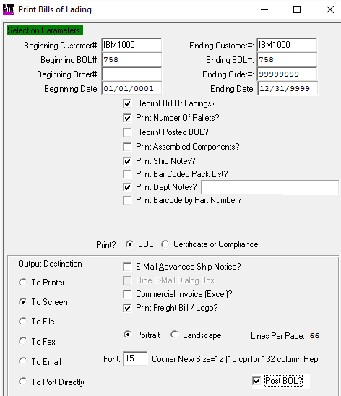

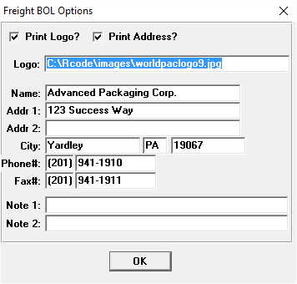

**ORDER PROCESSING - Invoicing**

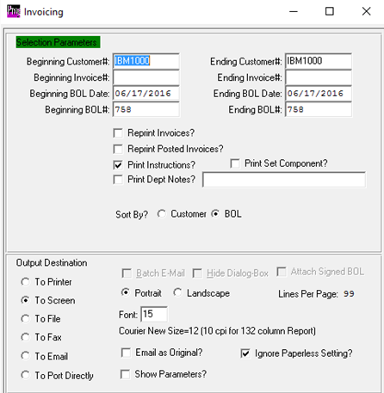

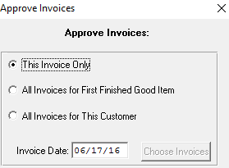

1. N-K-1 InvDate Bill of Lading Date or Current Date
2. **N-K-1 InvStatus SS Bill of Lading Print to post BOL to create Backorders & places Invoice W/F Approval**
3. **N-K 1 FGINVREC Invoice purchased Finished Goods when Received for P.O type are Drop Shipments?**
4. **N-K-1 BOLSign** M/S Explore Folder for Signed BOL’s PRINTER ICONS on Order Inquiry
5. N-K-1 OEPREP Invoicing Prep and Dies, Deleting Prep Code and Stop Duplicate Billing
6. N-K-1 OECLOSE Closing Orders During Invoice Posting by Inventory Balance
7. **Misc Charges O-F-6 Fuel Charges**
8. **Negative Quantity** Invoices as Credit Memos and Inventory Returns
9. **Counter Sales** Counter Sales for Cash or A/R
10. **Batch Invoicing Ecodes for Send To Contacts in Background**
11. **Invoice Options** Invoice per BOL, PO#, Group by Date with HOLD & Release
12. **INVOICE ONLY Invoice without Shipping and Shipping without Invoicing**
13. Customer Owned Inventory Reporting for Invoice Only Releases
14. **Paperless Invoicing Ecodes**
15. Credit Hold Placing Invoices on Hold by Customer, Order or Invoice

Order Processing Returns

# RETURNS VIA ORDER ENTRY

## N-K-1 BOLPOST Negative Release for Inventory Control

## Negative Bill of Lading

## Negative Invoice

## Order Quantity Properly Updated

## Bill of Lading Post for Negative Receipt (N-K BolPost Logical Values)

## Load Tags as Returns and new Tag Numbers

# RETURNS VIA LEVY RETURNS

## Add Return Authorization

## Print and Post AR Credit Memo

## Print and Post Finished Goods Return

**ORDER PROCESSING – OTHER MENU OPTIONS**

1. **N-K-1 OEImport Imports Customers Orders from Excel or XML**
2. O-W Web Orders imported from ASI Anyware
3. O-W EDI Orders imported from SAP Ariba Software
4. **N-K-1 RunShip Run & Ship – Manage Warehouse**
5. O-F-2 Order Entry Control File
6. O-F-3 Sales Price Matrix Commissions by Gross Margin, Sell Price or Gross Profit
7. O-F-4 Global Price Increase
8. O-F-5 Company and Company to Company
9. O-F-6 Company and Company to Company

Order Processing Reports

1. N-K-1 Reports View Form to define User Defined Report Writer by Report
2. N-K-1 CustomerList View Form to Secure Reports by User ID Customer Tab
3. O-Z-1 Xprint Report Format for Hots List showing PO Status, Routing and Release Status
4. O-Z-6 Xprint Report Format for Order Hot List by Release Status
5. O-Z-7 Xprint Report Format for Order Hot List by Open Order Status
6. O-Z-8 Xprint Report Format for Order Hot List 2 by Open Order Status
7. O-Z-9 Xprint Report Format for Order Balance by PO by Job#
8. Order Backlog by Salesman, Customer, Due Date, and Part Number
9. Orders Booked by Salesman, Due Date, Order No., Shipto, Part Number
10. O-R-2 Scheduled Release Reports by Customer, Sales Rep, Job and Ship to
11. O-R-9 Scheduled Release Reports with Style, Board and Job#
12. O-R-12 Scheduled Release Reports by Ship To Location Code
13. O-R-4 Sales Rep Performance
14. O-R-5 Booked Orders Report for Daily Sales
15. Commission Reports O-R-6, A-R-15 and O-F-7
16. **D**ata Change Reasons for Release Tab and O-R-14 for on time Deliveries

Order Processing Inquiries

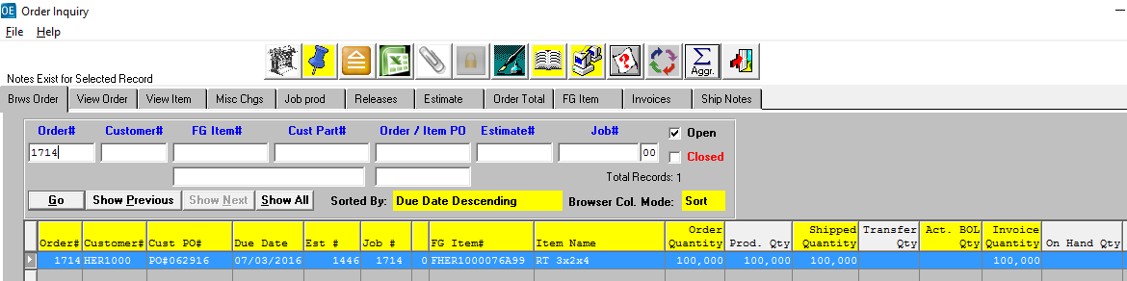

ORDER PROCESSING Summary of N-K-1 Control Parameters

1. ACKHEAD for order acknowledgment format selection.
2. ADDRELSE for adding release method and bypassing the release processing.
3. AUTOREL to release all items simultaneously.
4. BACKLOG to secure printing the cost and profit on the order backlog report.
5. BOLCERT character value and View Form Tab options to print BOL Certificate of Compliance.
6. BOLFMT character value and View Form Tab to select the print format.
7. BOLFMTX character value to select the print format for Brokers.
8. BOLPOST logical value to create FG receipts for Tags. Character value to stop posting if quantity low.
9. BOLWHSE to dictate where inventory is reduced. Shipto via Remote Warehouse or FGBIN from Item.
10. CASECNT to display warning if order quantity not devisable by case count? Logical value to Yes.
11. CASHSALE to allow cash sales to update general ledger cash. Log value to no to force cash receipt.
12. CLOSEJOB to automatically close job during finished goods posting, invoice posting or manually.
13. CUSTOMER Security password and credit fields to secure by defining character value for each field.
14. CUSTPASS to define security password for updating customer file.
15. FGITEM# to create finished goods number as customer part number, manually or assign unique code.
16. FGOECOST for cost order by full cost or factory cost.
17. FGFGRECEIPT to control when FG receipts are created.
18. FGPOCOST to transfer cost from purchasing for purchased finished goods/farm outs to order entry.
19. INVCOPYS no longer necessary with new print screen.
20. INVPOST to allow posting invoices when the cost is zero?
21. INVPRINT for invoice print format and date value as default for print selection screen.
22. JOBQTY to create the job quantity based on net sheets or gross sheets and overrun % from order.
23. JOBCREAT to create job via order entry. Also to set prefix to job number when added via J-U
24. JOBCARD to define job ticket format.
25. NOTES to show notes for department NT during order entry. Department NT must be created.
26. OEAUTOPO to automatically create purchase order for board during order entry.
27. OEBROSW to limit number of records displayed on browser screen.
28. OECARRIER to transfer the carrier from either the ship to file or the order header record.
29. OECOMM to determine the commission calculation or manual entry and to display or hide commissions.
30. OECOUNT to determine order entry count default as case/bundle count or pallet count.
31. OECLOSE to dictate when the order is closed.
32. OECREDIT to determine continued utilization of the credit hold logic after an order was approved.
33. OEFGUPDT to update finished goods file from the order entry fields modified during order entry.
34. OEINQ methods for displaying B-I-1 and hot keys on inquiry. To show due dates set log value to No.
35. OEITEM to allow adding orders for another customer’s items. This excludes Customer X items.
36. OEPARTS to display corrugated set components when quantities are below levels.
37. OEPROMPT to display error message when duplicate non blank purchase order numbers are used.
38. OEPOPUP to Display Spec Notes per Finished Goods Item
39. OEPREP to automatically delete billable Prep codes from estimate to prevent rebilling.
40. OERELEAS to create scheduled releases automatically when adding orders?
41. OEREORDR to calculate items allocated quantity on release quantity or order quantity.
42. OESHIP to ship components of an unassembled Set on separate bill of ladings.
43. OEREORDR to use total order quantity or release quantity for quantity available on order entry screen.
44. RELCOPYS is now unnecessary due to new print screen.
45. RELPOST to create Invoice, Nothing, BOL per Release or BOL with releases combined by ship to /date.
46. RELPRINT for release ticket format. Also as date default for the To Date when printing.
47. RELPACK for heading to be printed at the top of the release ticket.
48. SECURITY code to request password when printing reports that show commissions and profits.